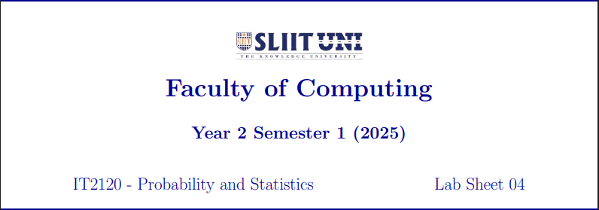

Abeysekara J.S.P.L.

IT24100370

3.This is a Right-skewed distribution.

